Basic Operations of the

Sony DFC-F707 Digital Still Camera

Complete manual located at
P:\Administration\Procedures\Equipment Manuals\Sony DSCF707 digital camera.pdf

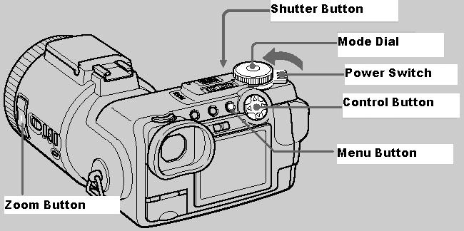

Turning the Camera On
Slide the Power Switch in the direction of the arrow to turn on the power.
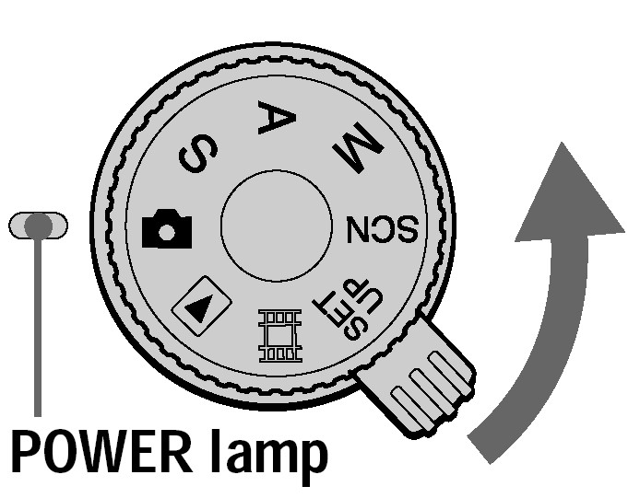

Operation of the Mode Dial
The Mode Dial switches the function that is used for recording, playback or editing.

The most commonly used modes are:
 | To record still images
 | To play back or edit images
SET UP | To set the SET UP items

Operation of the Control Button
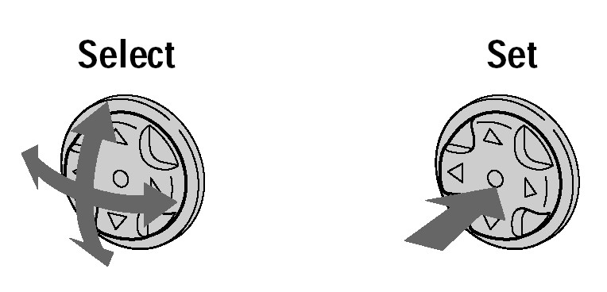

Changing Camera Options
When the Menu is not displayed on the LCD Screen, the Control Button is used to perform the following operations:
Up | Record with flash
Down | Record with self-timer
Left | Check the last recorded image
Right | Record close subjects

When the Menu or SET UP Menu is displayed, the arrow keys on the Control Button are used to move between the possible options, and pressing the center of the Control Button sets options.

Menu Button
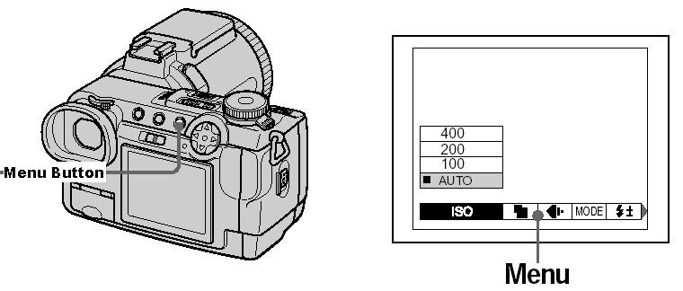
Press the MENU button to turn on/off the operation buttons (menu) on the LCD screen.

Note on photo resolution and quality:

In most cases, a setting of 1280 x 960 for resolution and a photo quality of Standard will suffice (i.e. photos that will be emailed, used on the web, etc. If these setting are not used, it may be necessary to manually edit the photos before emailing them/posting them on the web.). If high quality/resolution images are needed, resolution should be changed to 2560 x 1920 and photo quality should be changed to Fine (i.e. detail photos, photos that will be used in printed publications).

Determining and Setting Image Size

Resolution and Quality Setting | Used for: | Capacity of 128mb card:
1280 x 960, Standard Quality | email, web | Approximately 392
2560 x 1920, Fine Quality | detailed photos, printed publications | Approximately 88

- Set the Mode Dial to:
- Press the MENU Button.
- Press the right/left arrows of the Control Button to change the image size. Using the up/down arrows of the Control Button, select the appropriate resolution.
- Press the right arrow of the Control Button and select the appropriate photo quality.
- When finished, press the MENU Button to exit the screen.

Recording Still Images
- Set the Mode Dial to:
- Press and hold the Shutter Button halfway down.
- After the camera beeps, press the Shutter Button completely down.

Using the Self-Timer
- Set the Mode Dial to:
- Press the down arrow of the Control Button.
- Press the Shutter Button. The picture will take about 10 seconds after the Shutter Button is pressed. A beep will sound until the picture is taken.

Using Zoom Function
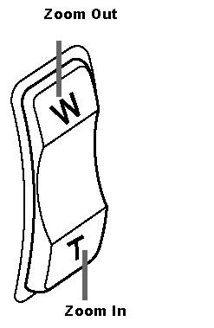

The Zoom Button is located on the side of the lens, and is marked with a
W (for wide angle, zoom out) and T (for telephoto, zoom in).

Deleting Photos
- Set the Mode Dial to:
- Select the picture you want to delete by using the left/right arrows of the Control Button.
- Press MENU
- Select [DELETE] with the right arrows of the Control Button, press the center of the Control Button.
- Select [OK] with the up/down arrows of the Control Button, press the center of the Control Button.

Viewing Photos
- Set the Mode Dial to:
- Use the left/right arrows of the Control Button to scroll through the photos on the memory card.

Downloading Photos
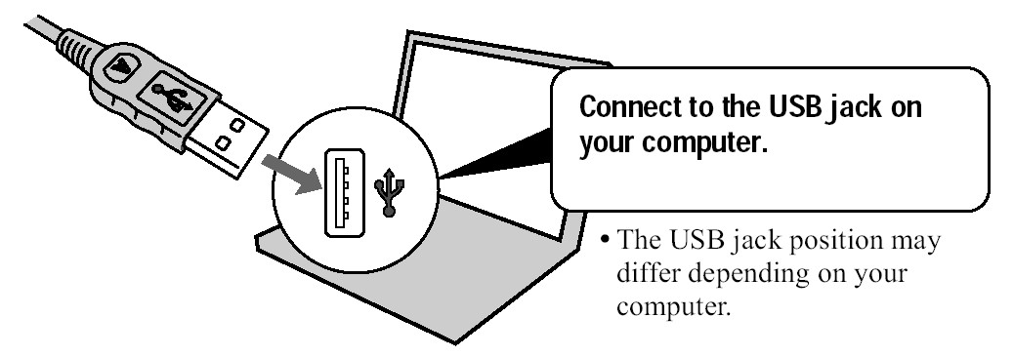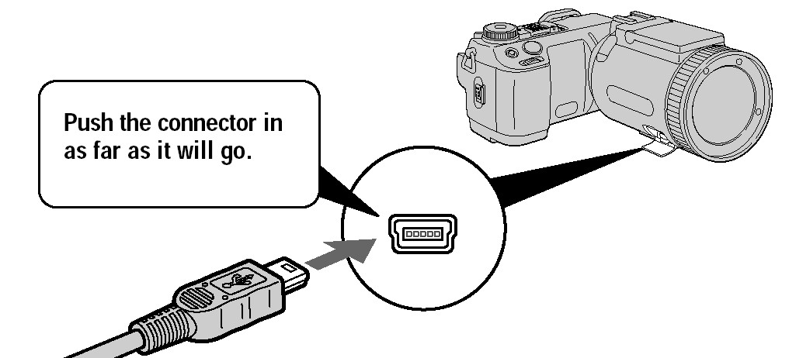

- Plug the USB Cable into the camera and your computer.

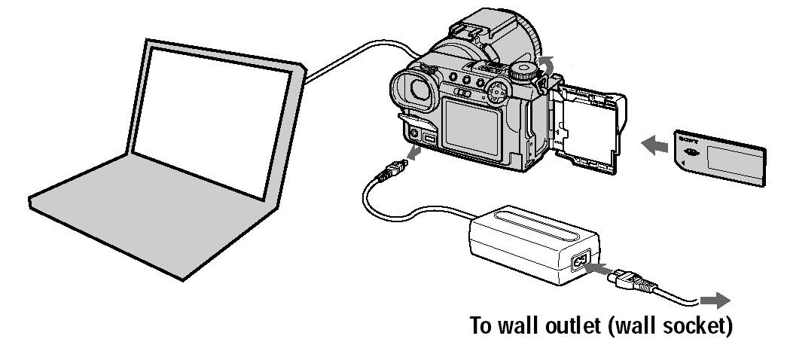

- Plug the DC adapter into the camera and into a wall outlet.
- Slide the Power Switch to turn on the camera.
- Download the pictures
  - If you are using the Windows XP, follow the onscreen prompts to download the pictures.
  - If you are not using Windows XP, additional drivers will need to be installed. Get assistance from the IT department or refer to the Sony Instruction Manual to install the drivers which are on disk in the large camera bag.

Recharging the Battery
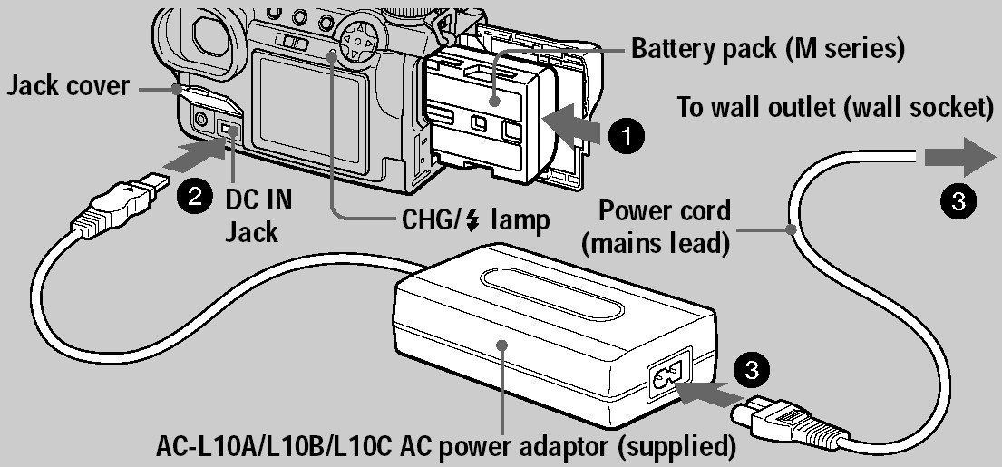

- Insert the battery pack.
- Connect the DC connecting cable to the DC in jack on the camera, as shown.
- Connect the power cord to the AC Power adaptor and then into a wall outlet.

NOTE: There is a spare battery in the hidden compartment of the camera case.

