VTC Quick Reference Manual

A. Getting Started 2
B. Booting the System 3
C. Audio Teleconference 4
To Dial Out: 4
To Add a call to the connection: 4
To End the Call: 4
D. Video Teleconference 5
To Add a Video Call 6
To Add a Telephone Call 6
To Disconnect a Video Call 6
Adjusting the Camera 7
E. Displaying a Computer Screen 8
F. Playing Video 9
DVD/CD 9
VHS 9
F. Recording a Session 10
G. Shutting Down 11
Frequently Asked Questions 12
Audio 12
Video 12
General 13
Facts/notes 14
Numbers 14
System Information 14

Getting Started

Before using the VTC equipment, please familiarize yourself with the following information.

The VTC Mobile Station is the unit located at the front of the conference room. Items included in this unit are: the cabinet on wheels, the Sony Monitor/Receiver, the Polycom Viewstation FX, and several network-related items.

These directions are for use with the Creston Touch Screen (CTS). The Main Screen (Fig. I), is the interface from which most directions will be completed. The interface that boxes the display area (olive-green part of the screen) will always stay the same. Please review the location of the buttons of the screen and their functions:

  - The audio visual sources and computer sources are located across the top of the screen. These buttons are green and include: CODEC FAR END, VCR, CD/DVD, TABLE FRONT and TABLE REAR. An additional source button, CABLE TV, is located on the left of the screen.
  - The command buttons are located on the left side of the screen. They are grey and include: PROGRAM VOLUME, CODEC DIAL, VIDEOTAPE SESSION, AUDIO DIAL, and PROJECTOR POWER.
  - The previews of the computer screen and video sources which are connected to the system are shown on the right side of the screen. The SYSTEM OFF Button is also located here.

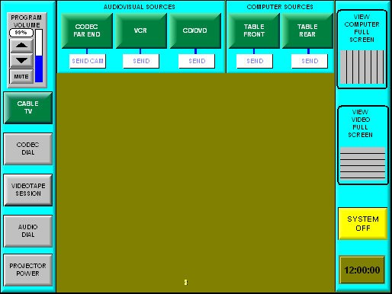
Fig. I, Main Screen

The VTC Unit MUST be shut down and the power-strip must be turned off after each use. For details on this process, see section H.

- Booting the System

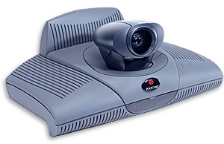
- Turn on the power-strip located inside the cabinet which houses Mobile Station Unit. The Polycom ViewStation FX (ViewStation, Fig. II) will boot. It is finished when the tone sounds and the green light on the front of the unit stays on.

- Touch the CTS to turn the system on (pressure sensitive).

Fig. II Polycom ViewStation FX

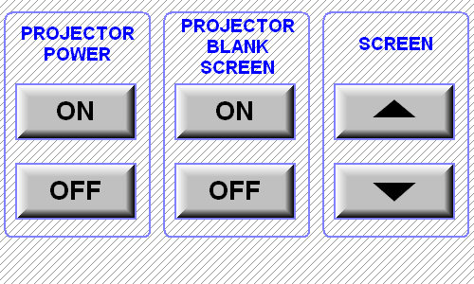

- Press PROJECTOR POWER from the Main Screen (Fig. I). The Projector Power Screen will appear (Fig. III).

- To turn the projector on, press Projector Power ON. The screen should automatically lower itself. If it does not, press the down arrow to do so.

Fig. III Projector Power Screen

- The projector will begin warming up. When the light on the bottom of the projector turns solid green, the projector is ready.

Projector light indications:
*Alternating green and red flashing lights means there is an error – contact Lyndon or Colleen.
*Flashing green indicates the projector is either cooling down or warming up.
*Solid green indicates the projector is projecting.
*Solid red means the projector is connected to power and is ready to be turned on.

- To begin projecting, press the green button corresponding to your input source (ie.CABLE TV, CODEC FAR END, TABLE FRONT, etc).

- If the screen does not project, press PROJECTOR POWER. Check to see if PROJECTOR BLANK SCREEN is turned on. If it is, press OFF, to turn it off.

Audio Teleconference

(You are dialing from 646–0520) – Dial 9 first

To Dial Out:
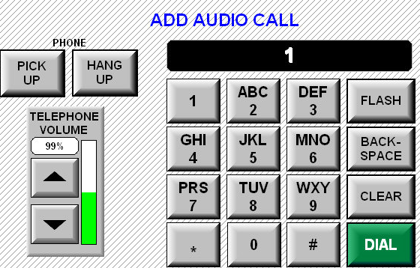

- From the Main Screen (Fig. I), press AUDIO DIAL. The Audio Call Screen (Fig. III) will appear.

- Use the on-screen numeric keypad to enter the number you want to call and press DIAL to connect.

Fig. III, Audio Call Screen

To Add a call to the connection: (repeat for each additional party up to 5 )

- Tell the caller that you will be putting them on hold to connect an additional party to the conference. Warn them that there will be a loud tone upon connection of the new call.
- Press FLASH to put the caller on hold and get another line
- Dial the number of the next party. The number will not show up on the screen.
- When connected to the new party, tell them that they will hear a loud tone as you connect them to the conference. Press 3 to connect the new party to the existing conference.

To End the Call:

- Press HANG UP. Each caller connected to the conference may hang up individually, but your only option is to disconnect all callers at once.

Video Teleconference

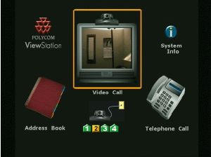

- Press CODEC FAR END. The ViewStation Calling Screen (Fig. IV) will be projected.

Fig. IV, ViewStation Fx Calling Screen

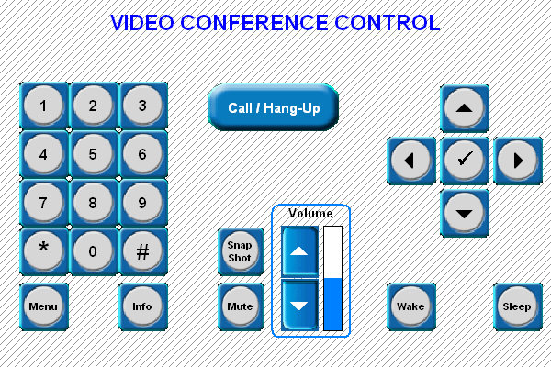
- Press CODEC DIAL. The Video Conference Control Screen, VCC (Fig. V) will appear on the touch panel screen.

- Use the arrow keys to highlight Video Call on the projection screen.


- Press the check mark, CM (Fig. VI ) to select. The Video Phone Screen (Fig. VII) will be projected.

Fig. VI, Check Mark, CM
Fig. V , Video Conference Control, VCC

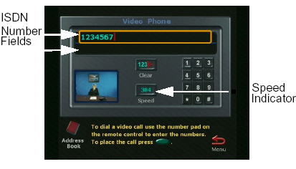

- Highlight the Speed Indicator, and press the CM.

- Highlight the appropriate speed **, and press the CM.

** Use 384 for one outbound call, 256 for two outbound calls, and
128 for three outbound calls.

Fig. VII , Video Phone Screen

- Enter the number you want to call and press the CM to connect, or highlight the Address Book and choose the desired number there.

- Use the on-screen numeric keypad to enter the number you want to call and press the CM to connect, or use the arrows keys to highlight the Address Book, and press the CM. Use the arrow keys to choose the desired number and press the CM to select.

- A series of circles will appear on the bottom left of the screen. When they all fill up to be 100% green, the call has been connected.

To Add a Video Call
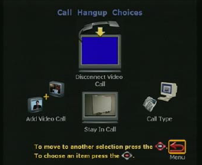
- Once the first call is connected, press CALL/HANG UP on the VCC Screen. The Call Hang Up Choices Screen (Fig. VIII) will be projected.

- Highlight Add Video Call, and press the CM.

- Use the on screen numeric keypad enter the number you want to call and press the CM to connect, or use the arrows keys to highlight the Address Book, and press the CM. Use the arrow keys to choose the desired number and press the CM to select.

- Repeat these steps for each additional call.

Fig. VIII , Call Hang Up Choices Screen

To Add a Telephone Call
- Once the first call is connected, press CALL/HANG UP on the VCC Screen.
- Highlight Add Telephone Call, and press the CM.
- Enter the number you want to call manually or use the address book.
- Repeat these steps for each additional call.

To Disconnect a Video Call
- Press CALL/HANG UP on the VCC Screen.
  - To disconnect a single caller, push the corresponding # on the VCC numeric keypad.
  - To disconnect all callers, Press CALL/HANG UP again.

Adjusting the Camera

- Near-Site Camera (this is the camera in the conference room – “US”)

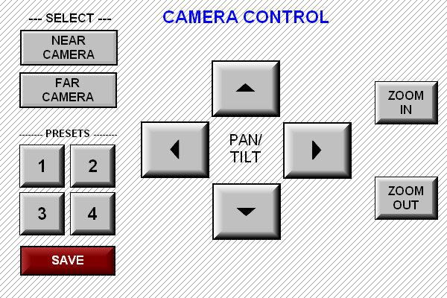

“US”
- Press the CODEC FAR END button on the touch screen. The Camera Controls Screen (Fig. X) will appear.
“THEM”

- Press NEAR CAMERA
  - Press Arrows to pan/tilt.
  - Press ZOOM buttons to zoom in and out.

Fig. IX, Camera Controls Screen

Presets may also be used for the control of the Near-Site Camera
(NOTE: ensure that the wheels of the mobile cart are positioned on the 4 markings on the carpet)

The presets are as follows:
- Far End of Table (1 person)
- Far End of Table (~3 people)
- Far End of Table (up to 10 people)
- Whole Room (13 people +)

- Far-Site Camera (This is the camera of the party you called – “THEM”)*

- Press the CODEC FAR END button on the touch screen. The Camera Controls Screen (Fig. X) will appear.
“THEM”

- From the Camera Controls Screen, Press FAR CAMERA
  - Press Arrows to pan/tilt.
  - Press ZOOM buttons to zoom in and out.

* Far-Site Camera can only be adjusted if the Far-Site has ‘Far Control of Near Camera’ setting enabled. This will also only work with a two-way videoconference (you and one other party).

Voice Activation Mode - if one person speaks for 3 – 4 seconds, a full-screen view of that person will appear (will switch from Hollywood Squares view).

“THEM”

Displaying a Computer Screen

- Using the VGA cable at either end of the table, connect to the VTC unit.
- Once connected, a thumbnail version of your computer screen should appear in the upper right hand corner of the main screen in the View Computer Full Screen section.
- Press TABLE FRONT (Connection nearest Projection Screen) or TABLE REAR to view your computer screen through the projector.
**Unless you are in a Video Teleconference, do NOT press the SEND button.
- To toggle between views (projector or laptop or projector and laptop), hold the Fn (Function) key and press F3 on your keyboard.

Note: Before disconnecting the VGA cable from the Crestron unit, it is necessary to select a different audio-visual source (ie. CABLE TV, VCR). If this is not done, it may be necessary to re-boot the system before it can be utilized with a different audio-visual source.

Playing Video

DVD/CD
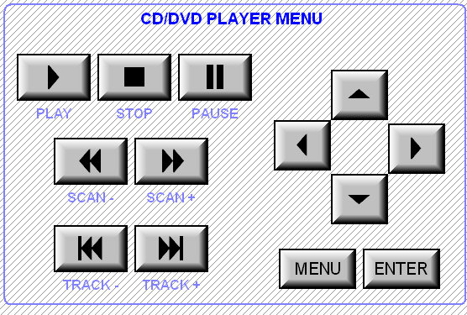
- Place the DVD or CD into the DVP-NS400D player.

- On the Touch Panel Screen, press DVD/CD. The CD/DVD Player Menu (Fig. X) will appear.

- Use the touch screen commands to control the disc.

Fig. X, CD/DVD Player Menu

VHS
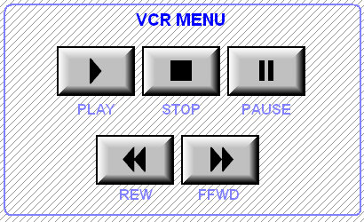
- Place the VHS cassette into the VHS VCR Playback unit.

- On the Main Screen, press VCR. The VCR Menu (Fig. XI) will appear.

- Use the touch screen commands to control the VHS.

Fig. XI, CD/DVD Player Menu

Recording a Session

This function will only work with a Video Tele-Conference – it will record what you are seeing on the projector screen while the VTC is connected *

- Before placing a video tape into the SVHS VCR-Recording unit, which is located behind the mobile unit, rotate the knob (channel selection and fast-forward/rewind) until L1 is displayed on the face of the VCR.
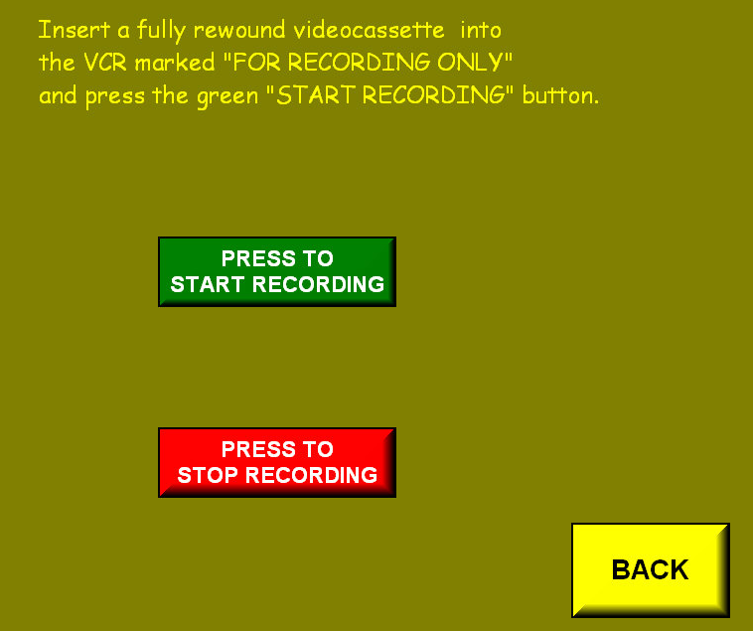

- Place a blank VHS tape into the SVHS VCR-Recording unit.

- From the Main Screen (Fig. I), press VIDEOTAPE SESSION. The Videotape Session Screen (Fig. XIII) will appear.

- To begin recording, press PRESS TO START RECORDING.

- To stop recording, follow step 3, then press PRESS TO STOP RECORDING.

Fig. XIII, Videotape Session Screen

* When recording a computer source, the VGA image will be converted to composite video. This will appear as a slightly smaller and blurrier version of the VGA image.

Shutting Down

It is necessary to shut down the system and turn off the power-strip after each use. To shut the system down, press the SYSTEM OFF button on the main screen (Fig. XIV). The power-strip must be turned off to complete the process. If this is not done, the projector, touch screen, and Polycom FX station will not be in sync with each other, and problems could potentially arise while the system is being used.

Press Here →
Press Here→

Fig. XIV, Main Screen

To Shut Down Press Here →

Frequently Asked Questions

Audio

Symptom | Cause | Solution
Why is there not enough volume during a call? | The volume is set too low on the monitor. | Turn up the volume on your monitor
Why is there not enough volume during a call? | The microphone pod is too far from the people speaking. | Move the microphone pod closer to the meeting participants.
Why does the ViewStation FX or VS4000 startup music play through the built-in ViewStation FX or VS4000 speaker but not through monitor speakers? | The monitor speakers or audio amplifier are not properly connected. | Check the volume level on your monitor.
Why are incoming call ring and other sound effects too loud or too soft? | The sound effects volume is not set at desired level. | Adjust the sound effects volume on the  Phone/Audio screen. If you do not want hear sound effects, set the volume to 0.
Where is there no audio in a call? | The monitor audio inputs are not connected properly. | Check audio output on the Generate  Tone screen under Diagnostics. You  should hear a 400 Hz tone emitting from the speaker.
Where is there no audio in a call? | The far site is muted. | Look for the far site Mute icon. Ask the far site to unmute its microphone pod.
Where is there no audio in a call? | Too many network line errors. | Disconnect call and reconnect later.
Why is an echo heard at the near site when speaking? | The far site microphone pod is too close to the audio speaker. | At the far site, make sure the microphone pod is placed away from the audio speaker.
Why is an echo heard at the near site when speaking? | The far site audio volume may be too loud. | Turn down the audio volume at the far site.

Video

Symptom | Cause | Solution
Why is the picture blank on the main monitor? | The system goes to “sleep” mode after 3 minutes of inactivity. | Pick up the remote control to wake up the system.
Why doe the picture freezes frequently during a call? | The network line transmission errors or IP LAN traffic is too high.  Check the error count under the  Diagnostics screen or try a lower speed IP call. | Check your system using the Near  End Loop test under the  Diagnostics screen. If the picture  does not freeze, tell the far site to perform the same test. If the picture  freezes, there are line errors on your  ISDN lines.  You can also test this by placing a video call to an ISDN loopback number provided by your service provider.
Why is the picture slow or jerky? | Only one 64 Kbps channel is connecting in your call. | Check the ISDN number of the far site. Ask the far site to call your site.
Why is the picture slow or jerky? | Lots of motion in the picture you are receiving. | A background with less motion provides a better, smoother video picture.
Why is camera voice tracking not working properly? | The camera tracking was turned  off by near or far site. | Camera tracking is turned off when the near or far site moves your camera. Press the AUTO button on the remote control to restore tracking.
Why is camera voice tracking not working properly? | The far site is speaking. | The camera stops tracking when the  far site speaks to prevent the camera  from pointing to your monitor speaker.
Why is camera voice tracking not working properly? | The far site is very noisy. | The camera stops tracking when the far site has a loud noise. Try setting  the ViewStation FX to track to camera presets.
Why is camera voice tracking not working properly? | Near-site is noisy or too many people talking at once. | Reduce the noise in the room.
Why is there a blue screen in the PIP window? | No video input. | Check that there is a video source present on the selected input.
Why is there a blue screen in the PIP window? | The camera selection is incorrect. | Check camera selection on the  Camera screen.
Why is there a blue screen in the PIP window? | The VCR input is selected and the VCR is idle or not running. Most VCRs generate a blue screen when the tape is not playing. | The VCR input is selected and the  VCR is idle or not running. Most  VCRs generate a blue screen when the tape is not playing.
Why doe the near site camera not pan or tilt? | You are attempting to move a camera that does not have pan/tilt/zoom capabilities. | Make sure you have selected a pan/tilt/zoom camera.

General

Symptom | Cause | Solution
Why does a slow blinking green light appear on the  front of the ViewStation FX or VS4000? | The system is sleeping. | System is in power save sleep mode.  This is normal. The system wakes up  on any action from the remote control  or on an incoming call.
Why does an amber light appear on the front of the  ViewStation FX or VS4000? | The system is in a call. | This is normal.
Why does a green light appear on the front on the  ViewStation FX or VS4000? | The system is not in a call. | This is normal.
Why am I not able to enter the Admin Setup menus? | System is password protected.  Password has been forgotten. | Go to the Diagnostics screen and perform a system reset. This erases  all your system settings except for your Address Book. You may then  enter a new password in the  Security screen.
Why does the system start in the Software Update screen? | System software is corrupt or not loaded properly. | Load system software on the  ViewStation FX or VS4000 from your  PC.

Facts/notes

Numbers:

203-747-7114 HB Communications Front Desk
203-747-7060

Some numbers you can call for VTC tests:
512-367-2593 Austin TX Polycom
203-747-7250 H. B. Communications North Haven Admin Conf Room (Dave Koss)
203-985-1841 H. B. Communications North Haven Main Conf Room
781-894-5987 H. B. Communications Waltham Conf Room

System Information:
System Name: ISTS
Video Numbers: 1.603.643-3301/2117
LAN Host Name: ISTS
LAN IP Address: 129.170.249.155 Ext. 177200
Software Version: Release 4.2Fx-27 Aug 2002
Serial #: 02b430
Model: VSFX:512:H:323

